Project Report

Course Name (NICF) | NICF Diploma in Business Analytics
Product Name (Marketing & Sales) | Professional Diploma in Data Science
Module Name (NICF) | NICF Data Science Essentials
Product Name (Marketing & Sales) | Data Science Essentials

Student name |  | Assessor name
Goh Rui Kun |  | Ryan
Date issued | Completion date |  | Submitted on
2nd Nov 2020 | 7th Nov 2020 |  | 7th Nov 2020
Project title | Student Registration Form Development

Learner declaration
I certify that the work submitted for this assignment is my own and research sources are fully acknowledged.

Student signature: RK Date: 7th Nov 2020

Content
- Project Overview 1
- Project Technical Environment 2
- Analytical Technique & Tools used 3
- Data Science Project Team – Roles and Responsibilities Table 3
- Activity 1: Activity Summary 4
- Activity 2: Flight DataSet- An Overview 5
- Screen-shots of each task of Activity 3 6
- Screen-shots of each task of Activity 4 7
- Screen-shots of each task of Activity 5 8
- Screen-shots of each task of Activity 6 9
- Screen-shots of each task of Activity 7 10
- Screen-shots of each task of Activity 8 11
- Screen-shots of each task of Activity 9 12
- Screen-shots of each task of Activity 10 13
- Screen-shots of each task of Activity 11 14
- Screen-shots of each task of Activity 12 15

Project Overview: Describe the Project with summary of analytical processes and project outcomes (Explain the Project in your own words in 15 – 20 lines)
In this project, We are going to create a predictive model with an user friendly interface: Excel as an output, for the user to input the flight information and forecast the duration of the flight delay or early in minutes.
We will be using Azure Machine Learning and R programming script which can be implemented together in the Azure Machine Learning platform.
The steps of the project implementation includes data flight dataset which are found in Azure Machine learning sample Dataset. This is a large dataset which could not handle by Excel, there are approximate 2.7 million rows and 14 columns. We will merge with other Dataset, perform data wrangling such as remove duplicates, cleaning dataset, select relevant columns features, select suitable Machine Learning Algorithm to train, test, score and evaluate the model results. We will be using Boosted Decision Tree Regression Machine Learning Model algorithm.
After the model have been trained, we will setup web services and deployed it. This is to benefit other users to access the predicted model via Excel using dedicated URL and API generated from the Azure Machine Learning platform. Users will be able to key in the predictor information to predict how long will the flight delay in terms of minutes.
Project Technical Environment: (Describe the Microsoft Azure Machine Learning Platform)
We will be using Azure Machine Learning platform from Microsoft to perform all the task. It provides a graphical user interface (GUI) for data scientist or Analyst to develop model using built in drag and drop features or object. For example, items to read data, clean missing data, remove duplicate rows, join data, normalize data, train, score and evaluate model. The model will be built on the canvas area, user will just need to drag and drop the item they need into the canvas and connect them together in sequences and execute it. For each experiment items, input ports are on the top and output is at the bottom, executing the results of each item can be visualized when right click on the output port and select visualize. Azure Machine Learning platform allows user to upload, download dataset, convert to CSV file, and connect to SQL database. There is sample dataset built in Azure Machine Learning as well. To enhance user experience further, Azure Machine Learning provide access code to connect it to your preferred Integrated Developer Environment (IDE) like PyCharm, R Studio and even Juypter Notebook. User can setup and publish as a web service with the trained model experiment to other users and utilize the model in Excel to forecast results from the model.
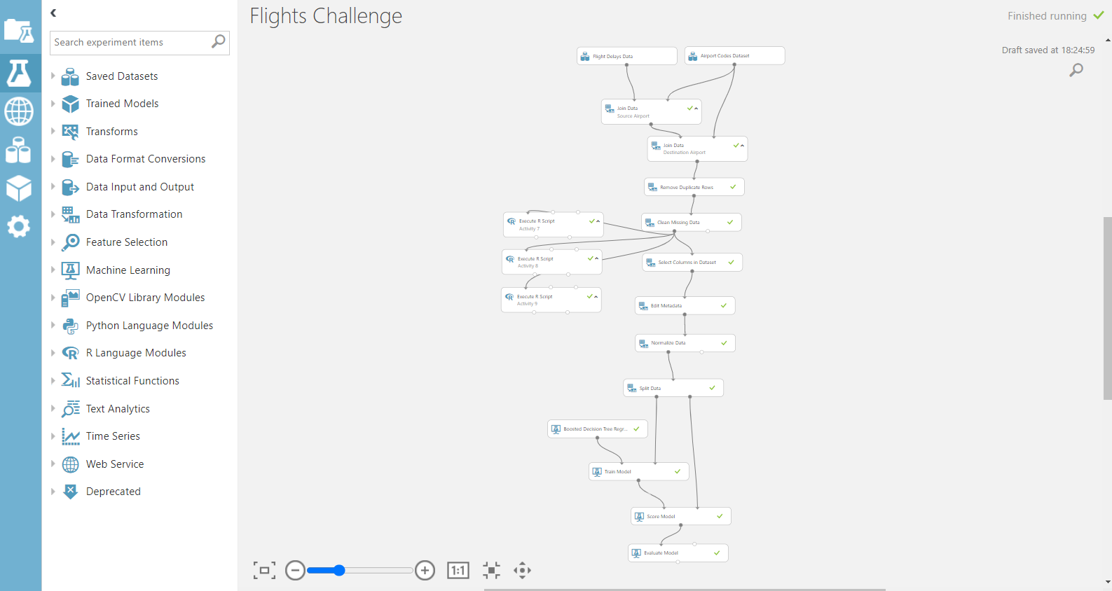
Analytical Technique & Tools used: Describe the Analytical Technique (Regression) and Tools used in the Project
In this Project, we are using Boosted Decision Tree Regression to train the model as the analytical technique. Regression analysis is commonly used in statistical modeling to estimate the relationships among variables. A general regression model can be represented as a formula of y = mx + c where y is called the label or dependent variables, or the variable that the model want to predict, x is called independent variables or predictor, m is the slope of the line and c is the y intercept.
Decision tree is a type of regression learning method where the flow starts from observations about the feature of x or the predictors, given the condition test to decide which way the flow should branch to and finally conclude the label value, y. Common tree models are for classification where the labeled variable take a discrete set of values and regression tree is where the label variable take continuous values.
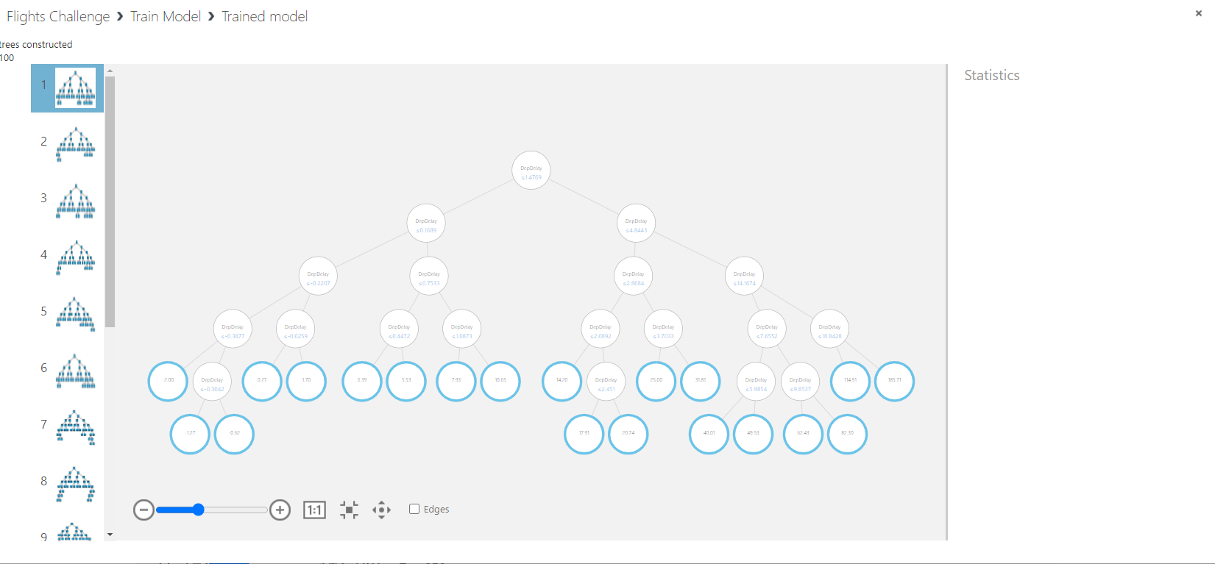
Boosted decision tree regression is a type of decision tree regression model which each tree is dependent on prior tree. The algorithm learns by fitting the residual of the trees that preceded it. Boosting in a decision tree tends to improve accuracy with some small risk of less coverage.
The setup of the model begin from identify the dataset to be used, join relevant data, remove duplicated rows and clean missing data, identify features for training, normalize data, split data, select training algorithm, train, score, evaluate model, select output column, setup and publish web services.
The key tools used in Azure Machine Learning Studio includes Data transformation for manipulations, machine learning process and web services to publish the result for the users usage.
- Data Science Project Team – Roles and Responsibilities Table
A data science project is often accomplished by a project team. The size of the project team can be different depends on the project scale and complexity. In a data science project team usually consists of a manager, data scientist, data analyst, business analyst, data architect, data engineer, data visualization engineer. It is not necessarily to have all of them to form the team depends on the size of the company and the requirements, one person might take up multiple roles within a project team.
Role | Responsibilities
Manager | Manage and lead the team, align the project goals with the stakeholders, get requirements to setup up the infrastructure and requirement, help to clear doubts or obstacles for the team. He is also act as a business translator that bridges the gap between data science and domain expertise to act both as a visionary and a technical lead.
Data Scientist | Solves business tasks using machine learning and data mining techniques. The role also identifies, perform data preparation, cleaning with further model training, tune the model and evaluation. He/she involves in leveraging company data to drive business solutions, performs data analysis and data mining, statistical methods to analyze data, using models like descriptive, diagnostic, predictive, prescriptive and unlock business value of data.
Data Analyst | Mainly involve in data collection and interpreted activities. He/she ensures that collected data is relevant and exhaustively interpreting the analytics results. He/she will bridge between technology and business, understand the business needs and works with Data Architects and Data engineer to design data systems, they will use pilots proof or concepts and work with business users and conduct workshops.
Business Analyst | Assists manager functions in converting business expectations into data analysis. He/she help to bridge the gap if data scientist lacks domain expertise.
Data Architect | Critical for working with large amounts of data or big data. He/she oversees performance in data warehousing, define database architecture, centralize data, and ensure data integrity across different sources. He/she uses data lake architecture and enterprise architecture from a data perspective, design the plumbing of data flows into and out or data lake, understands macro and micro level of data consumption and business requirements in multiple platforms and technologies.
Data Engineer | Implement, test, and maintain infrastructural components that data architects design. In most cases, the role of a data engineer and data architect can be combined as one person. He/she is responsible for developing, testing, and maintaining algorithms to deal with the raw data. He/she involved in data lake creation, data extraction, cleansing, transformation, loading (ETL) and process very high data volume.
Visualization Engineer/Designer | Build application data visualization for end users, facilitating an easy way to understand the data into visualization for the user to interpret and make decision. He/she develops static and dynamic data visualizations, user journey focused, involves in data driven decision making to visualize various types of data, involves in data storytelling.
Artificial Intelligence (AI) and Machine Learning (ML) Specialist | Use AI, ML, Deep learning, programmatic prediction and improvement, upgrades and tuning of models
In simpler form, Business analysts or Domain Experts will analyze the business problem, Data Engineers, Big Data Engineers, Data Quality Analysts and Big Data Architects will source, ingest, and store data. Data Engineers, Big Data Engineers, Extract, transform, load (ETL) Developers, Database Administrators, Data Quality Analysts will prepare, clean, and normalize data. Data Analysts, Python, Scala or R Developers, Business Intelligence Specialists, Data Scientists, Visualizers, Reports specialists will analyze data. Statisticians, Machine Learning Developers, Data Scientists will create predictive model. Machine Learning Developers and Data Scientist will deploy model.

- Activity 1: Activity Summary
In this project, we identified the goals to build a predictive model if the flight will arrive early or late at the destination in terms of minutes measurement. First, the preparation we determine the roles of a data science team and review the activities involved, setup and ensure technical development environment Azure Machine Learning platform. This involves running some sample experiment and machine learning model in Azure Machine Learning Studio. Second, the data cleansing, we will start on creating a new experiment and use the relevant sample dataset “Flights Delay Data” that was added into the experiment canvas. A quick data visualization will be performed to determine the number of rows in the dataset and the summary statistics like the mean value. Another sample dataset “Airport codes Dataset” is added to the experiment to be used as inner joined to “Flights Delay Data” to show the origin and destination airport name, city, and state. This will output the data with the most frequent occurring destination airport. Next the joined dataset will be cleaned by removing duplicated rows and replacing missing values using Azure Machine Learning data transformation tool like remove duplicate rows and clean missing data. The results will contain fewer rows after duplicate rows are removed and the mean of the ArrDelay column changed after the missing data are cleaned by replaced it with 0 values. Third, the data exploration, it aims to drill into the data to understand the relationships among the columns of data, via data visualization. This can be done using execute R script on the Azure Machine Learning platform. To visualize the distribution of the ArrDelay column, a histogram and boxplot is plotted. From the data visualization, it could be seen that the distribution is right skewed with large variation and most flight arrive close to their scheduled time. The dataset contains several numeric features columns such as DepDelay which is the number of minutes late that the flight departed or CRSDepTime column which is the departure time in 24-hour clock format. It would be interesting to explore the numeric columns if there is any relationship to the contribution to flight delay on arrival at destination. This can be visualized by plotting histogram of these factors and conditioned by ArrDel15 which is a categorical data that measure if the flight arrived late by more than 15 minutes or not. From the data visualization, it shows flights that delayed in departure tends to arrive late as well and there is some relationship to the specific departure/arrival time in the day. Another aspect of the numeric factors is to explore and directly compare their respective value and our labeled value “ArrDelay”. This can be done by plotting scatter plots between the numeric values and ArrDelay variables. We have added a dimension to the scatter plot and conditioned by the ArrDe15 factor. The data visualization shows a linear relation between ArrDelay and DepDelay on the scheduled departure/arrival time of the day. This data exploration activity helps to determine the key factors such as DepDelay, CRSDepTime, CRSArrTime that show more apparent relationship to the dependent variable ArrDelay allowing to emphasize on these columns of data for machine learning. Lastly, perform machine learning, before proceeding to actual machine learning, we select relevant columns of features for machine learning and making certain features such as airport ID and carrier as categorical data. Next, we will perform normalization on column DepDelay, CRSDepTime and CRSArrTime to scale them into same range using Z score transformation. This is to ensure the machine learning model perform better on the effects of each features. Next the dataset will split into 2, 70% for the train and 30% for test the trained model. Boosted Decision Regression Tree algorithm is chosen for its higher accuracy. After the model is trained and scored, we will evaluate the results and check the RMS Error and Coefficient. We will deploy to web service and published the model. User will only get the labelled output “ArrDelay” after keyed in the predictor columns using Excel software.

- Activity 2: Flight DataSet- An Overview
In the Azure Machine Learning Studio, create a blank experiment, select sample dataset “Flight Delays Data” & Airport Codes Dataset. The Flight Delays Dataset contain flight information such as the dates of flights, origin airport ID, destination airport ID, carrier, and delay information on both the departure and arrival. Airport Codes Dataset contain the information to join the airport ID to the airport name, city, and state. From the required from the project brief, the goal of the experiment is to apply K-Means clustering machine learning to identify how many different groups or clusters are present in the dataset, based on some sort of similarities among the cluster members
.
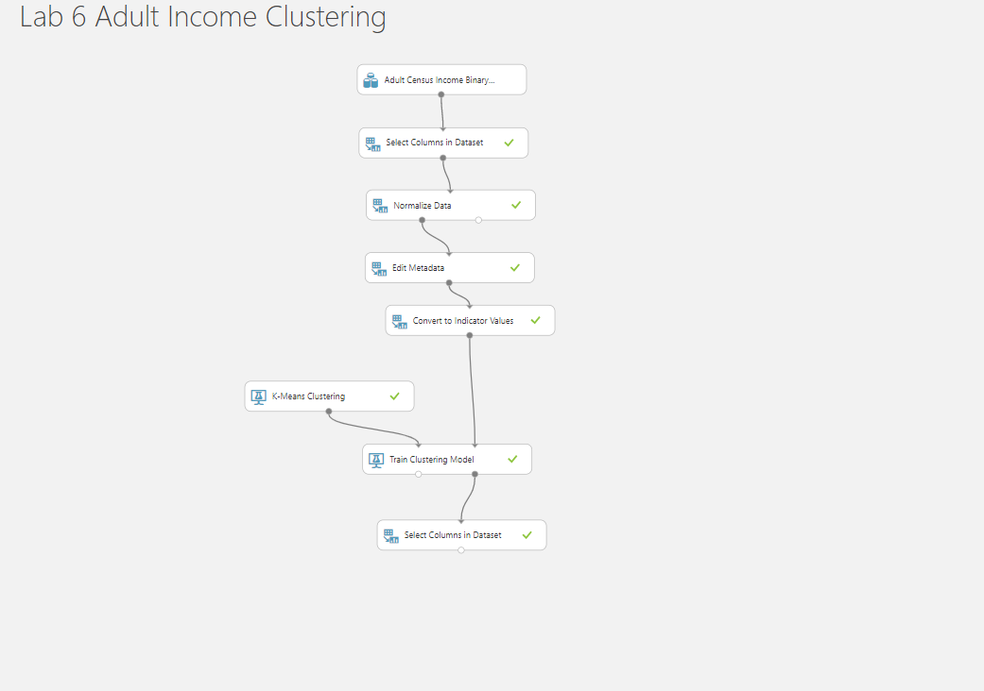
This is an unsupervised machine learning as there are no labeled column or specific category to group whether their income is less or more than 50k.
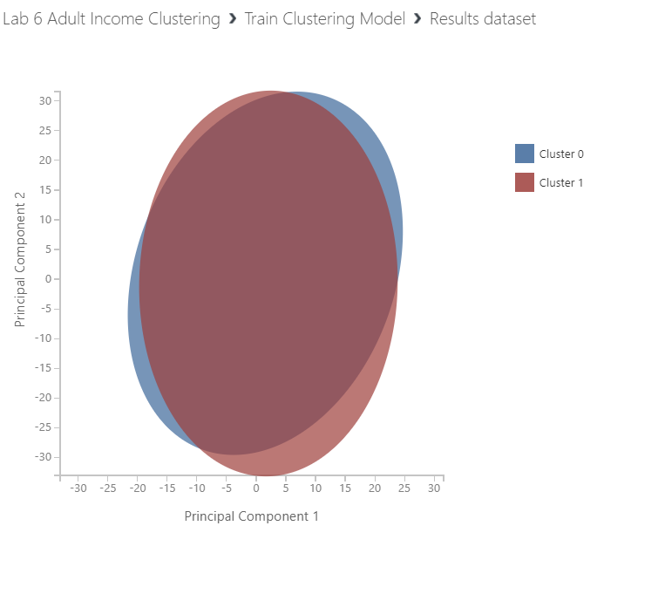
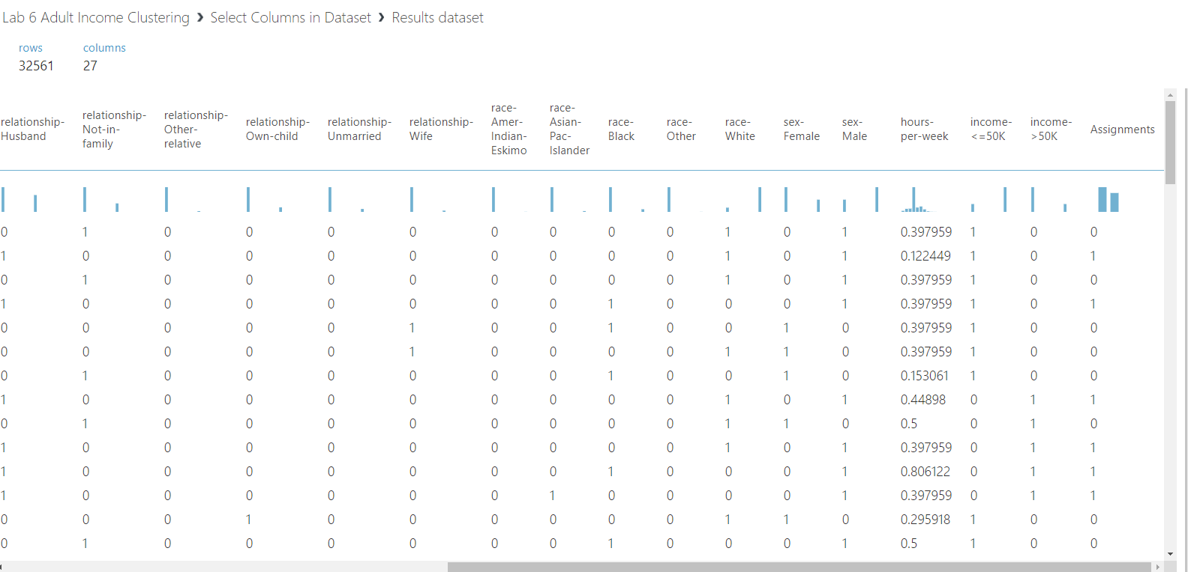
- Screen-shots of each task of Activity 3
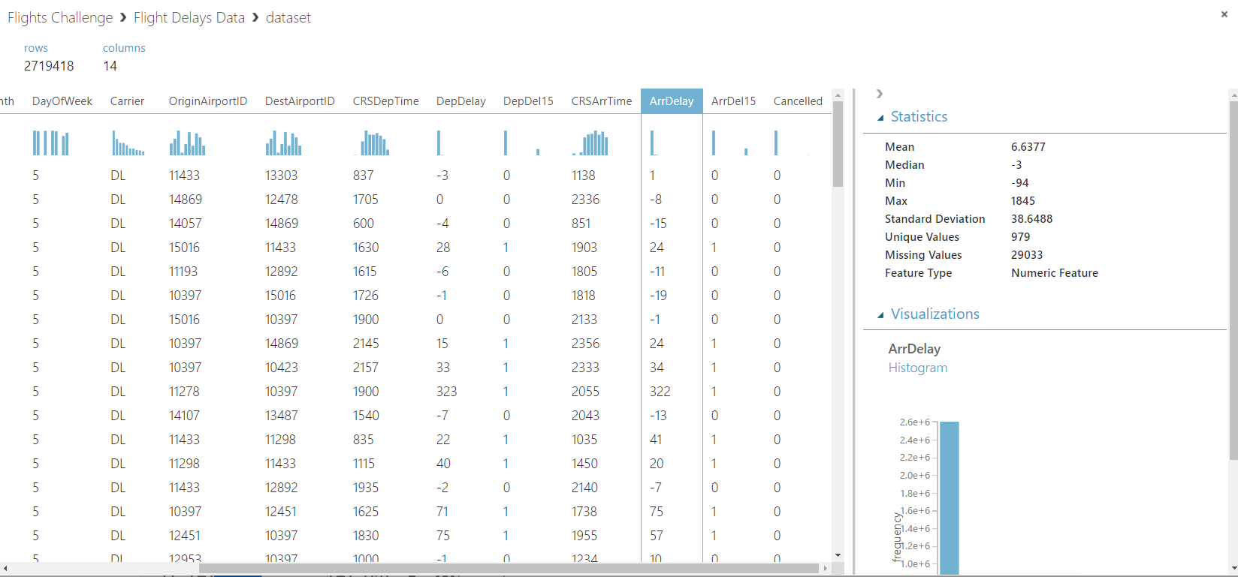
In the new experiment on Azure Machine Learning Studio, it is named Flight Challenge. The Flight Delay Dataset is added to the experiment canvas. The output result shows there are 2,719,418 rows and 14 columns. The mean value of ArrDelay column is 6.6377.

- Screen-shots of each task of Activity 4
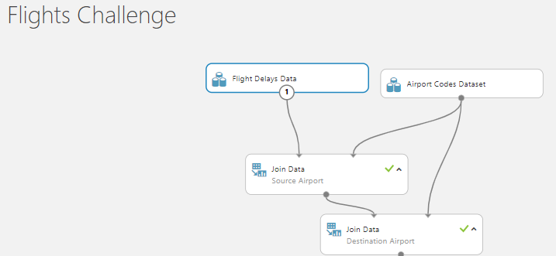
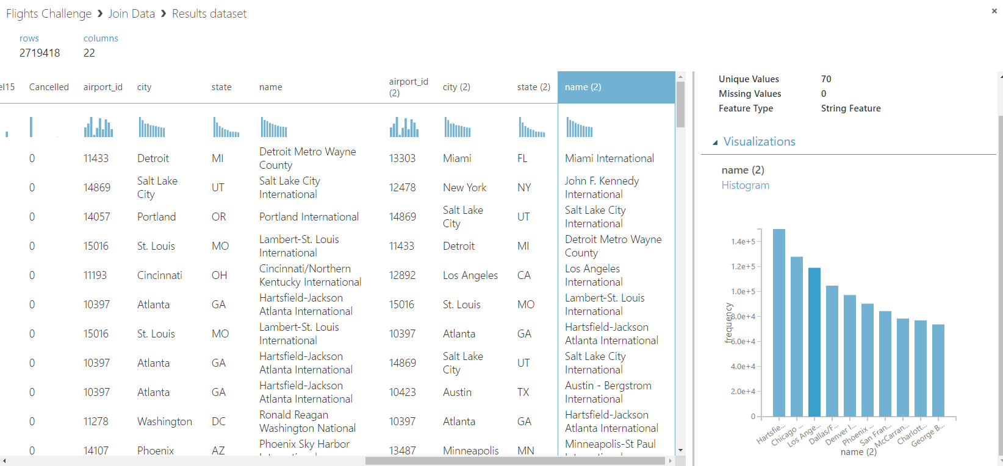
Airport Codes Dataset contain the mapping of airport ID to the airport Flight Delay Data are joined with the Flights Delay Data. After both datasets are joined, the joined dataset contains more columns which is now 22 columns compared to the previous 14 columns. As per the above histogram for the Destination name column the highest frequency is Hartsfield-Jackson Atlanta International.

- Screen-shots of each task of Activity 5
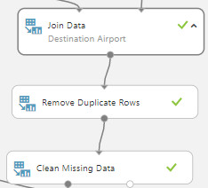
After the join dataset, the dataset will be cleaned by removing duplicate rows and replace missing data. Year, Month, DatofMonth, Carrier, Origin Airport ID, DestAirport ID, CRSDepTIme. CRSArrTime is selected for treating duplicates and keeping the first duplicate row. For the missing data or NA in column DepDelay and ArrDelay will be replaced it with value 0.
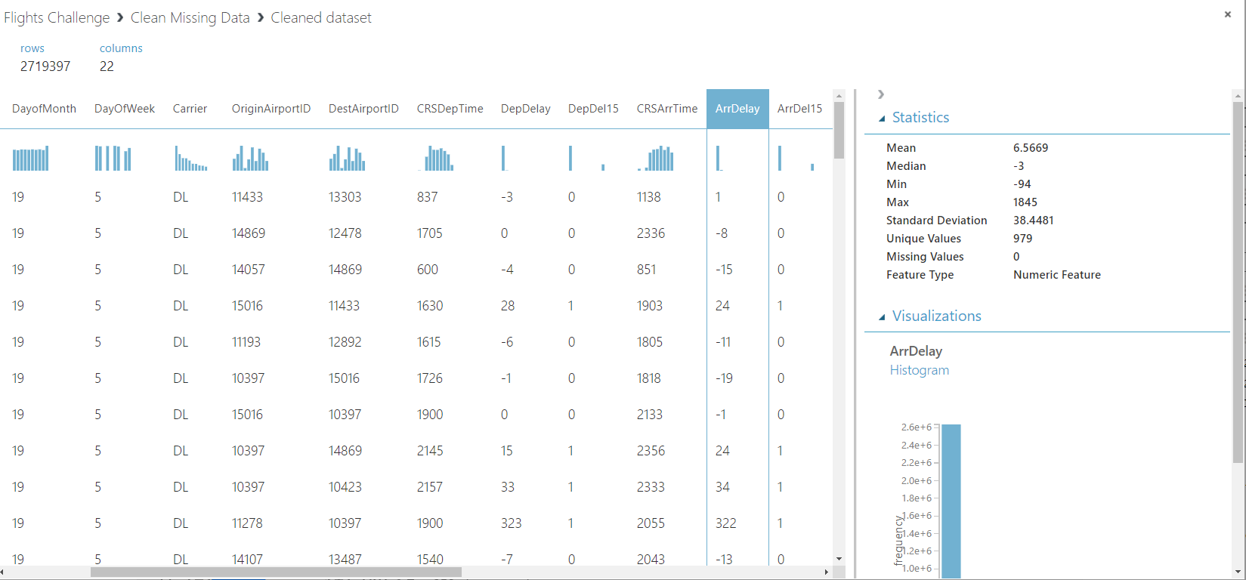
After the dataset had been cleaned, it remains to 2,719,397 rows with 21 duplicate rows removed and the mean value of ArrDelay column become 6.5669 which is lesser than before cleaning the dataset which is 6.6377.

- Screen-shots of each task of Activity 6
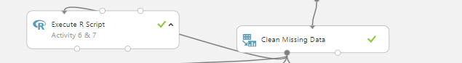
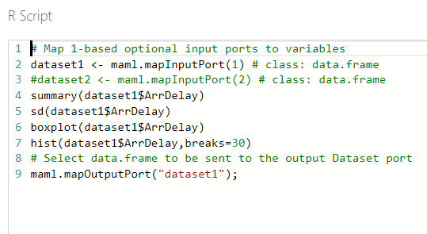
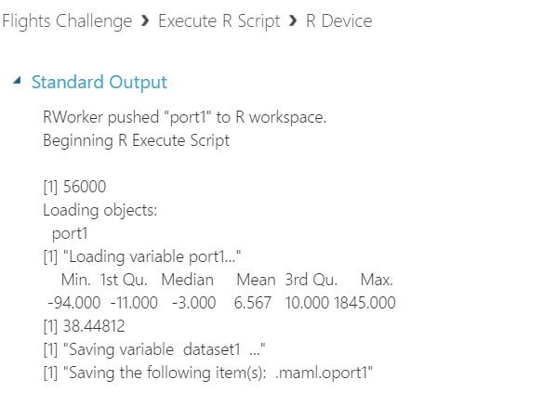
The summary statistics for the dataset is displayed using execute R script in Azure Machine Learning. The result for ArrDelay Min is -94, Mean is 6.567, Max is 1,845 and standard deviation is 38.44812.

11. Screen-shots of each task of Activity 7
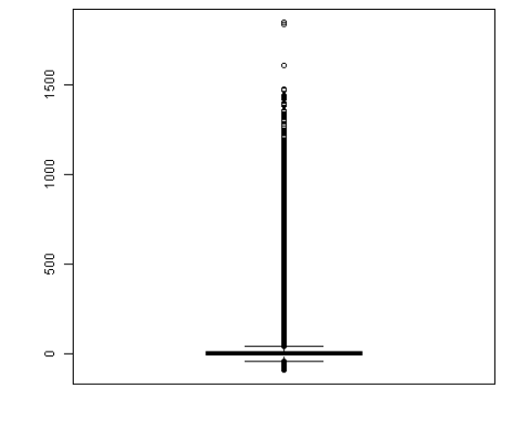
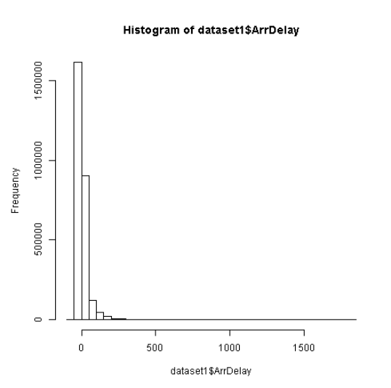
Question:
Based on the data visualization, which three of the following statements accurately reflect the distribution of ArrDelay values?
1. The median, first quartile, and third quartile are all fairly close to 0, indicating that most flights arrive close to their scheduled time.
2. The distribution is evenly spread across the range of values, indicating that flights are equally likely to be early, on-time, or late.
3. The median indicates that the majority of flights are 500 minutes late or more.
4. The range of arrival times ranges extensively, with some flights arriving as much as 1500 minutes late.
5. The distribution is right-skewed, so there is a higher range of values for late flights than for early flights.
6. The distribution is left-skewed, so there is a higher range of values for early flights than for late Flights.
Answer:
Statement 1, 4, 5 is correct.
From the box plot prove that statement 1 is correct as the median, first quartile and third quartile is close to 0.
Statement 2 and 6 are false as the histogram is right skewed distributed, however statement 5 is correct.
Statement 3 is false as the median from the boxplot shows it is close to 0 not 500.
Statement 4 is correct as from the boxplot shows that there are some flights arriving 1,500 and some even more than that.

- Screen-shots of each task of Activity 8
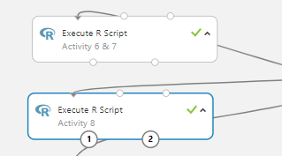
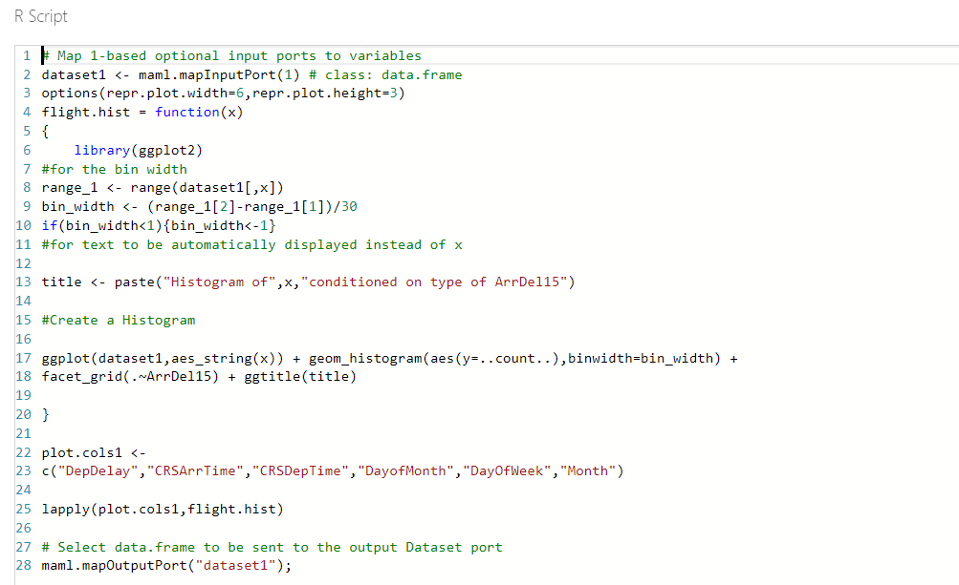

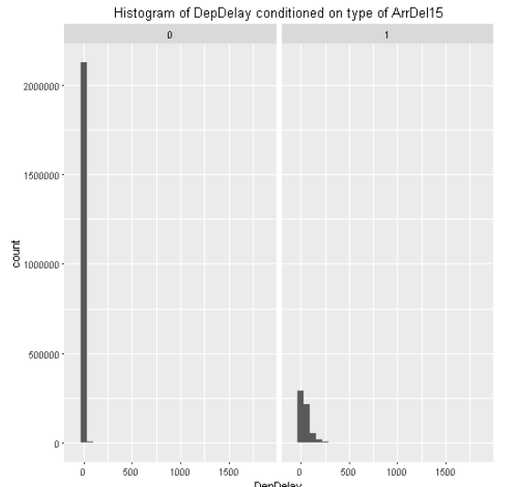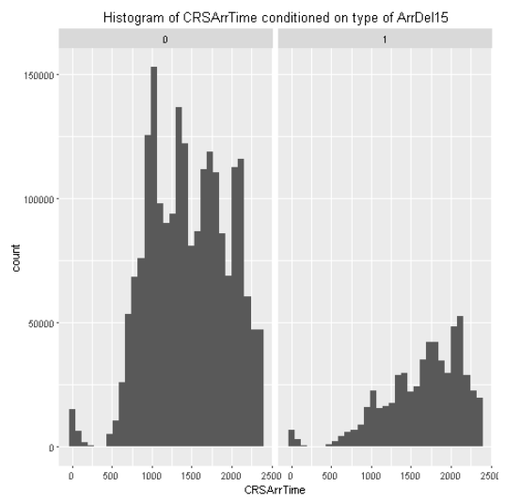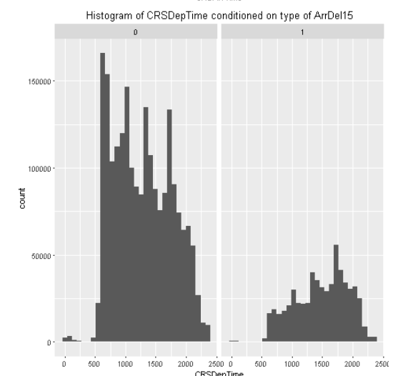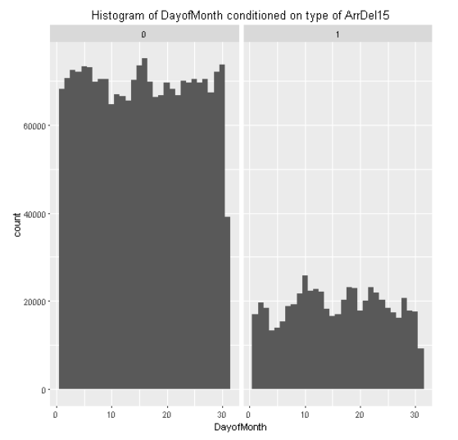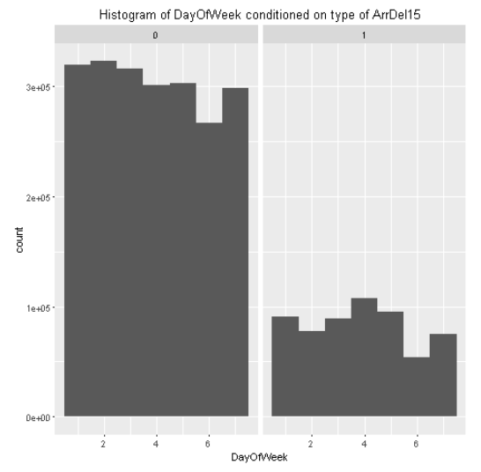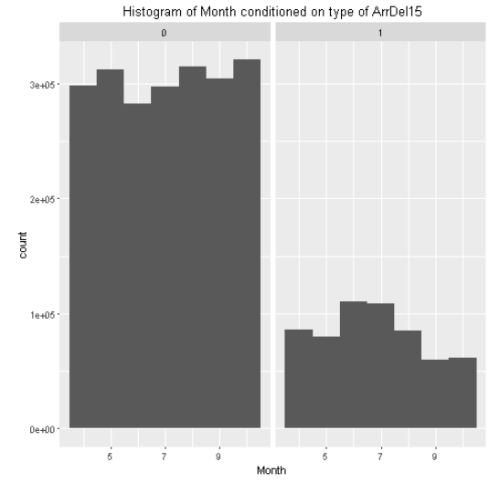
Question:
Based on the conditioned histograms, which three of the following statements are true?
1. There are significantly more flights that are less than 15 minutes late than there are flights that are 15 minutes late or more.
2. Late flights tend to occur more frequently at the beginning of the month.
3. Flights that are 15 minutes or more late tend to have a higher DepDelay value than flights that are on-time.
4. Late flights tend to occur more frequently for flights with a CRSArrTime that is later in the day, the highest volume of delayed flights scheduled to arrive between 3pm (1500 hours) and 8pm (2000 hours)
5. The relative distribution of late flights varies significantly from that of on-time flights based on the day of the week.

Answer:
Statement 1, 3 , 4 are correct

From most of the histogram plots, ArrDel15 = 0(False) shows that there are more flights than ArrDel15 = 1, so statement 1 is correct.
From the Day of Month histogram, there is not much different throughout the month, so statement 2 is not correct.
From the DepDelay histogram, the ArrDel15 = 1 distribution is spread out while ArrDel15 = 0 have a frequency of 0 only, so statement 3 is correct.
From the CRSArrTime histogram shows that the volume is the highest between 1500 to 2000, so statement 4 is correct.
From the DayofWeek histogram does not show much significant difference, hence statement 5 is not correct.

13. Screen-shots of each task of Activity 9
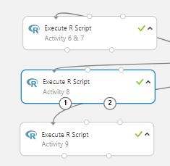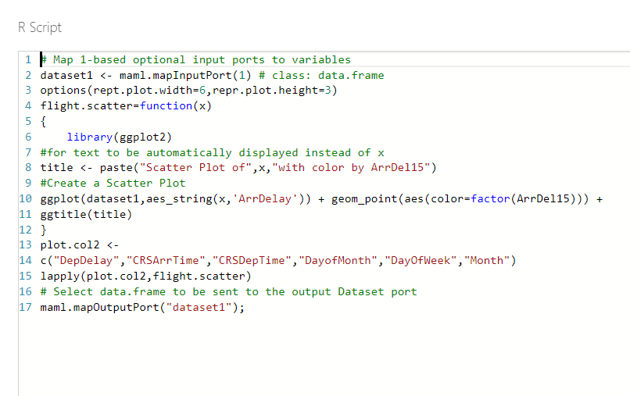
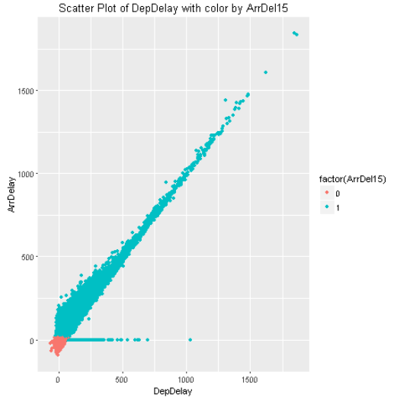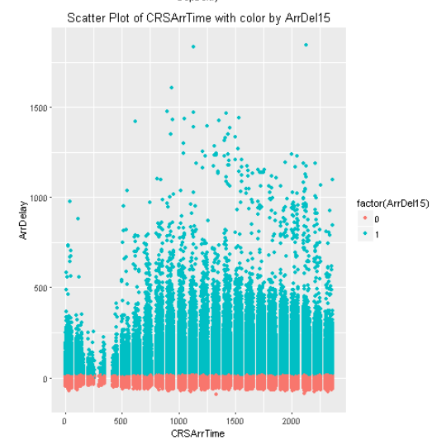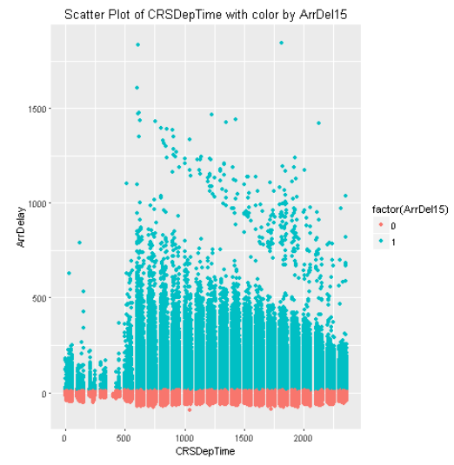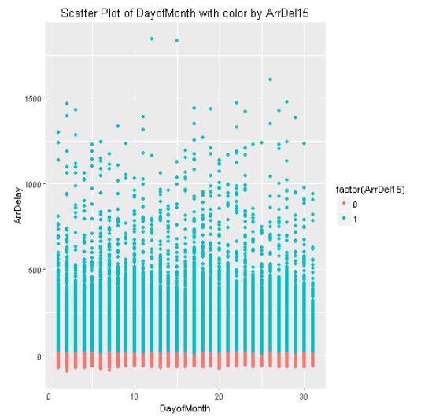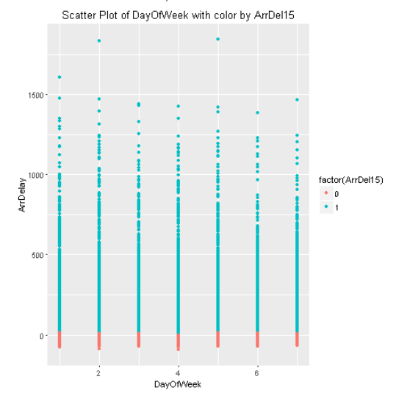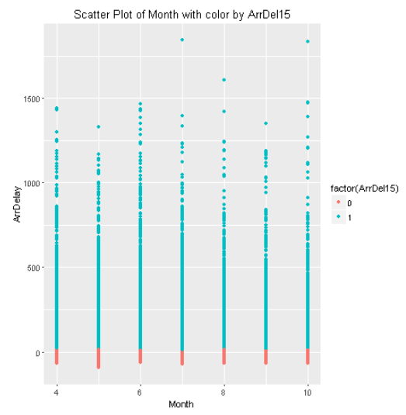
Question:
Based on the conditioned scatter plots, which two of the following statements are true?
1. There is a clear relationship between ArrDelay and month. Later months of the year show
markedly longer delays.
2. There is a near-linear relationship between DepDelay and ArrDelay for late flights. As departure
delay increases, so does arrival delay.
3. There is a clear correlation between ArrDelay and DayofMonth. Earlier days of the month show
markedly longer delays.
4. There is an apparent relationship between ArrDelay and CRSDepTime. Flights that depart early in
the morning are typically less delayed than flights that are scheduled to depart after around 5am
(0500 hours), at which time delays tend to get significantly longer. Delays then gradually get shorter as the day progresses.
Answer:
Statement 2 and 4 are correct.
From the ArrDelay vs Month scatter plot does not show any significant relationship, so statement 1 is not correct.
From the ArrDelay vs DepDelay scatter plot shows a significant linear relationship, so statement 2 is correct.
From the ArrDelay vs DayofMonth scatter plot does not show significant relationship, so statement 3 is not correct.
From ArrDelay vs CRSDepTime scatter plot show less green dots after 5am and gradually become lesser, so statement 4 is correct.

14.Screen-shots of each task of Activity 10
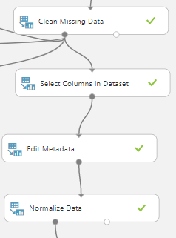
After the data cleansing is done on Azure Machine Learning, we use the Select Columns in Dataset module and select Month, DayofMonth, DayOfWeek, Carrier, OriginAirportID, DestAirportID, CRSDepTime, DepDelay, CRSArrTime and ArrDelay columns for training the model. This is to reduce unnecessary data use to train the model and save time and cut cost. Next, we convert OriginAirportID, DestAirportID and Carrier column into categorical. Next, we normalize the data using the Zscore transformation on CRSDepTime, CRSArrTime and DepDelay, bringing them to similar scale.
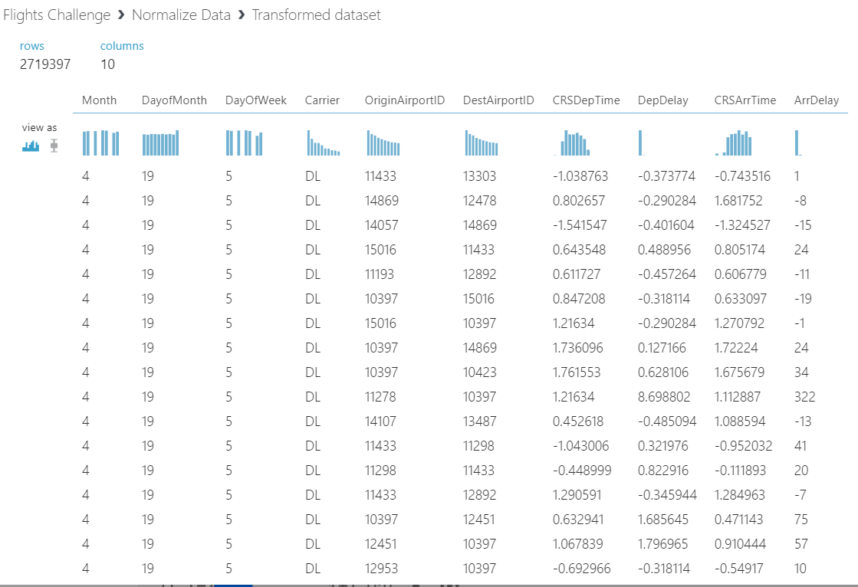

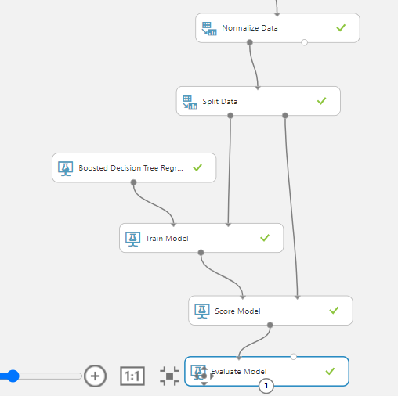
Next, the dataset will split into 70% training data and 30% testing data using the train model module. Since the predicted output “ArrDelay” is continuous data, involved categorical features, numerical features, and some time features, boosted decision tree regression model is chosen. 70% of the training data will be trained by the boosted decision tree regression algorithm. Next the result of the trained data will be used to test the 30% testing data using the score model module and will be measured by the Evaluate model.
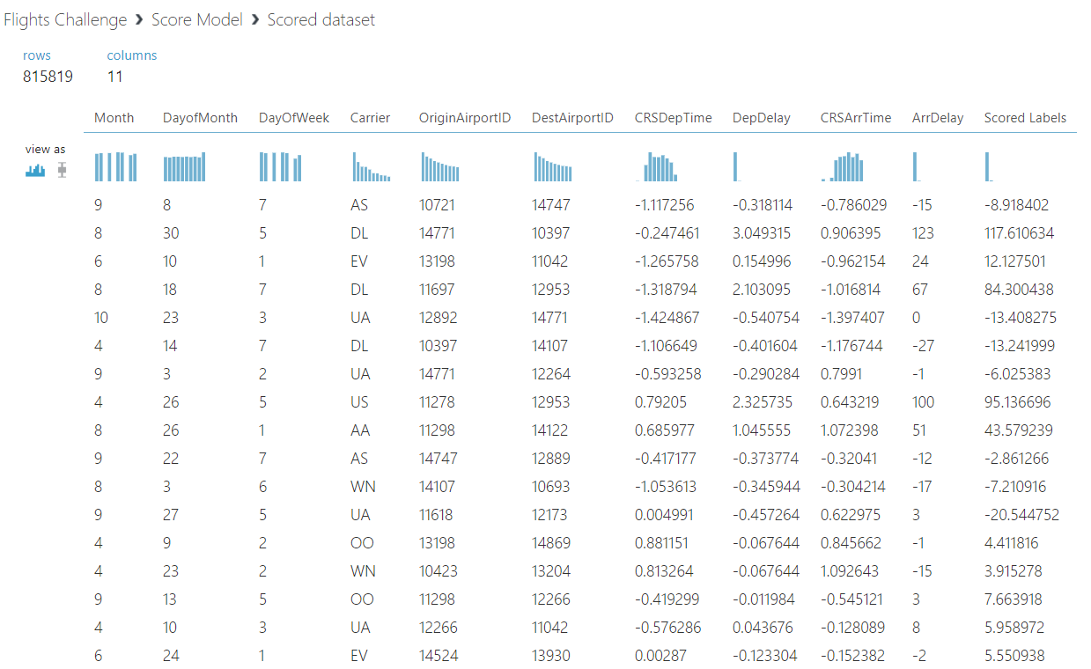

15.Screen-shots of each task of Activity 11
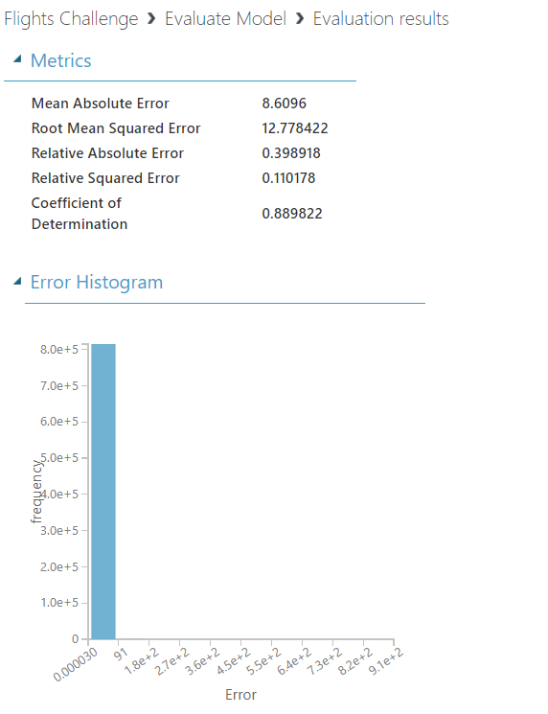
After running the experiment is completed, visualized the Evaluate Model result. The Metrics shows that the Root Mean Squared Error is 12.778422.

16.Screen-shots of each task of Activity 12
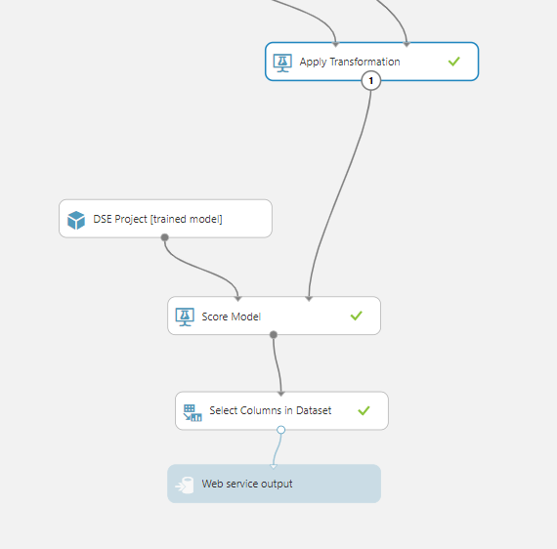
After running the experiment as web service, a predictive experiment will be created in the Azure Machine Learning Studio. Next insert Select columns in Dataset module between Score Model and Web service output. Then select scored label column, so the user will only get the predicted value as output instead of all the columns.
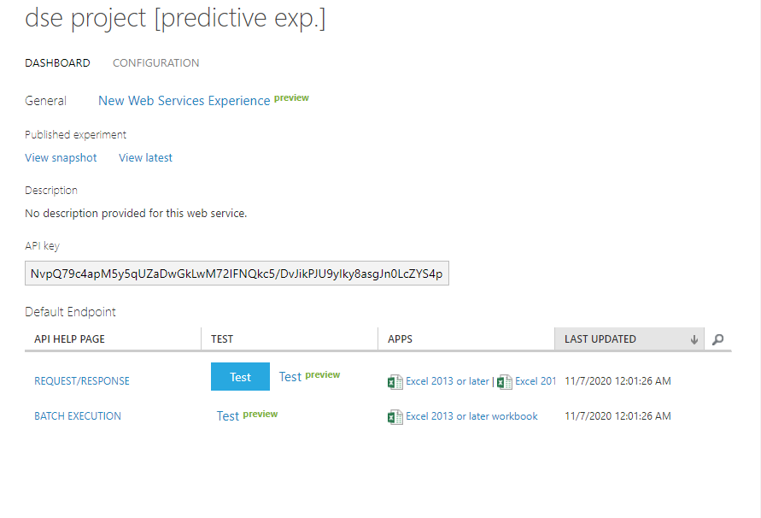
After saving and run the modified predictive experiment, deployed it to web services, click on Excel apps. Right click on Request/Response and copy the link and paste it on the Excel URL fields. Next copy the API key and paste it on the API field.
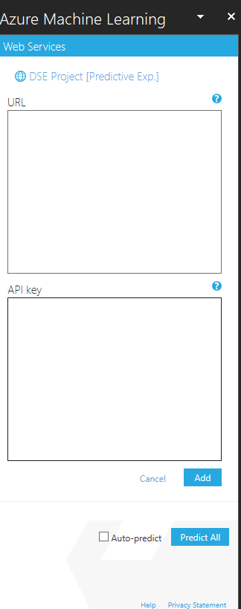

In Excel, insert Azure Machine Learning apps via Insert/My Apps, input URL and API key and the model will be ready for use.
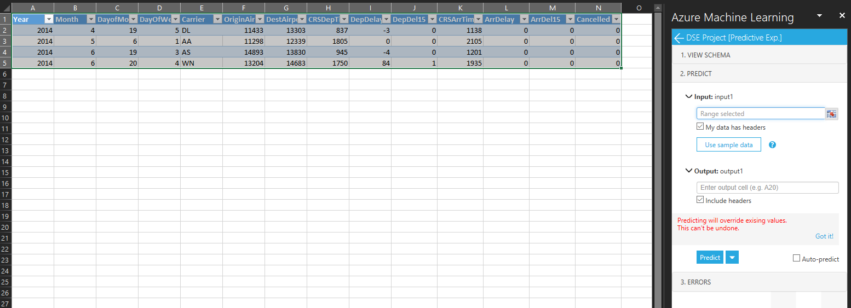

Input the sample data and define the input and output range in the Excel. Next runs predict.
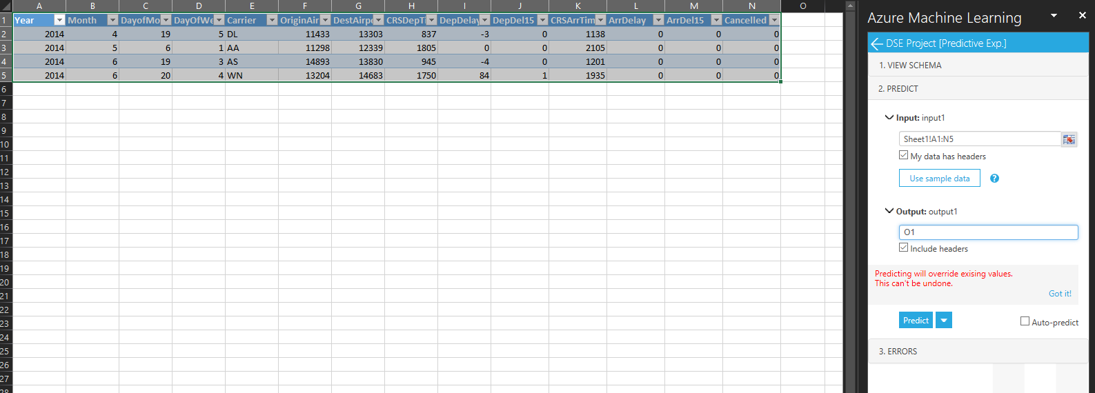
Key in the data, define the input and output range
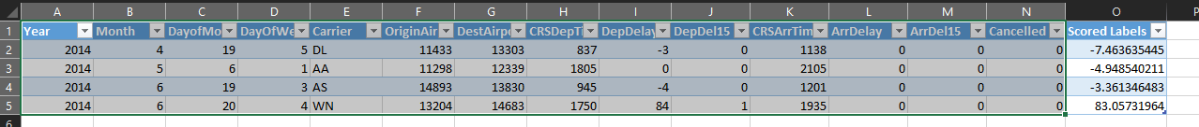

The predicted values are, -7.463635445, -4.948540211, -3.361346483 and 83.05731964.

